**Data Loading and Initial Overview**

**Code**

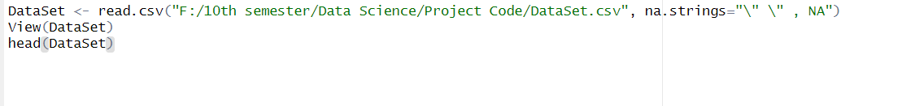

**Output**

**Summarize Dataset**

Provides a detailed summary of the dataset using skimr.

**Code**

**Output**

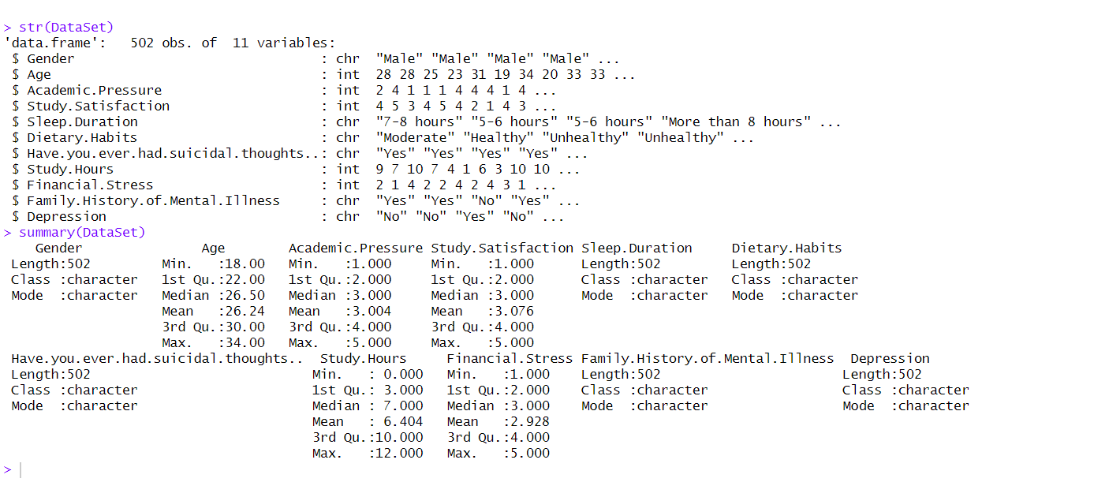

**Define Column Types**

**Code**

**Output:**

**Summary Statistics for Columns**

**Description**

Prints the summary of numeric columns and counts unique values in categorical columns.

**Code**

**Output**

**Numeric And Categorical Column Define**

**Code**

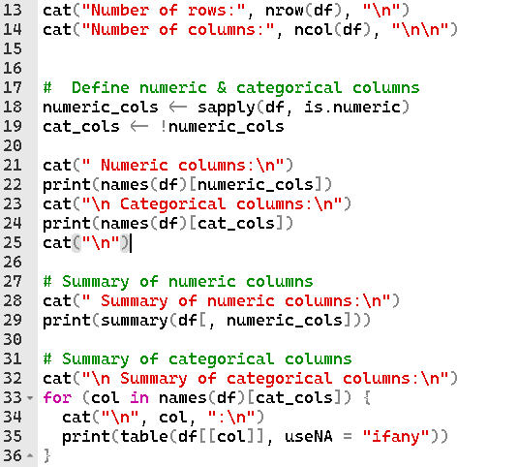

**Output**

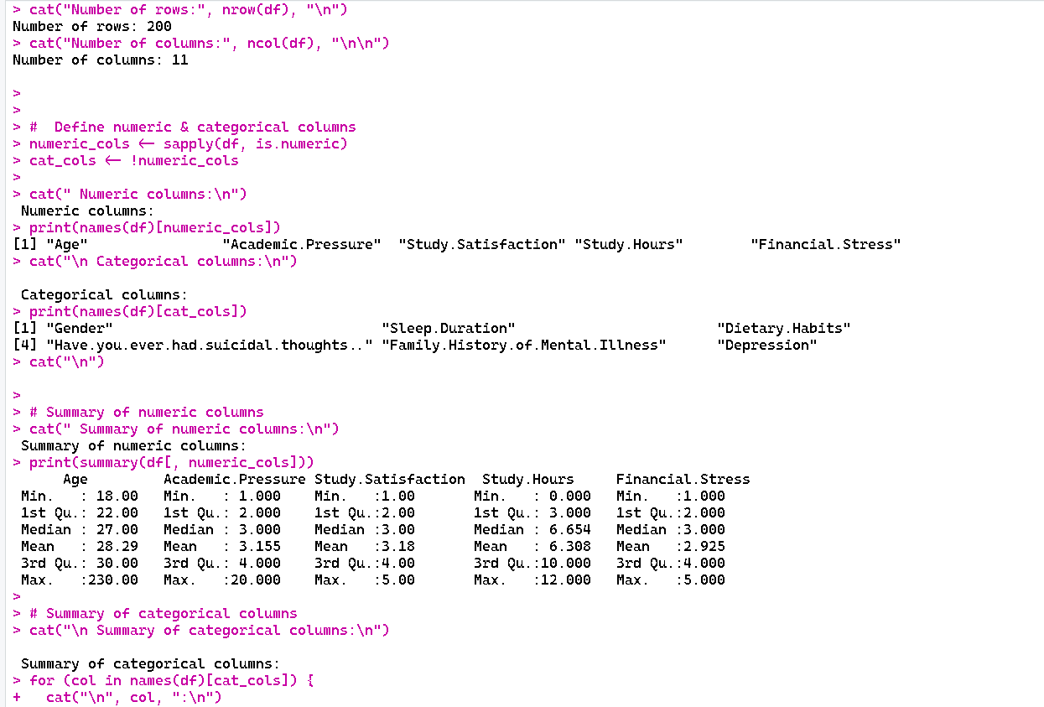

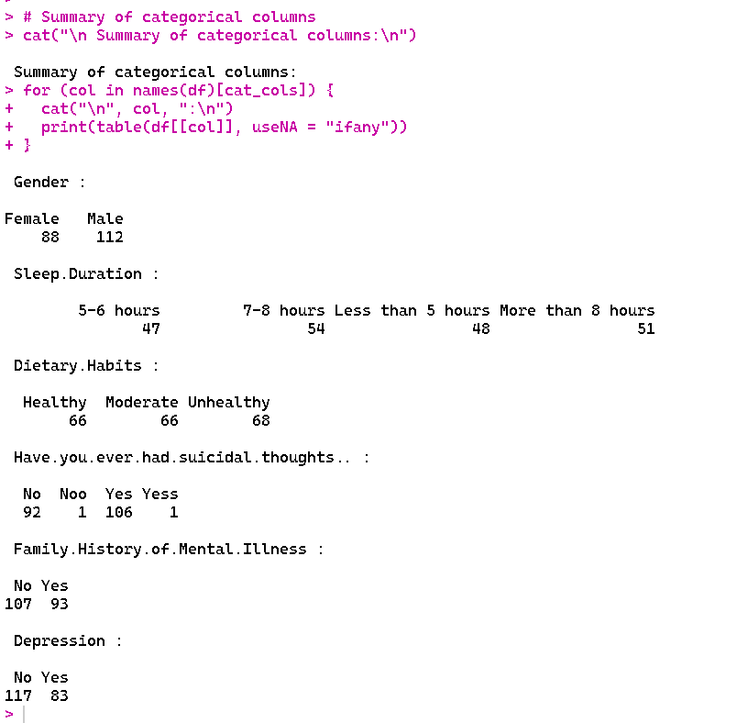

**Check for duplicate**

**Code**



**Output:**

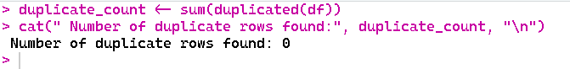

**Handle duplicate**

**Description**

remove duplicate row if there has any duplicate row.

**Code**

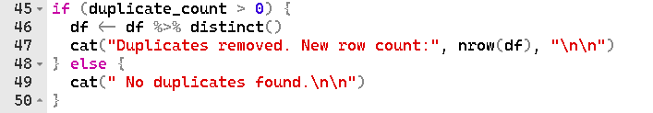

**Output:**

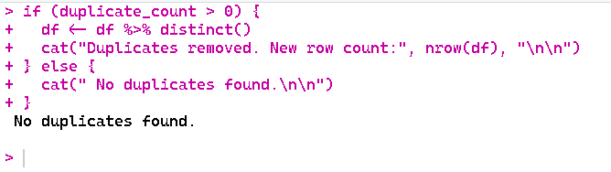

**Missing values**

**Description**

Check the null value and there has any missing value then Convert missing values to NA

**Code**



**Output:**



**Null Value**

**Code:**



**Output**

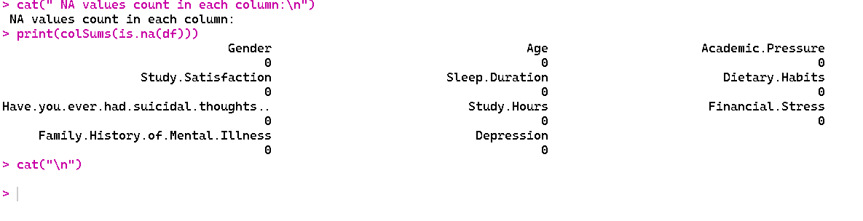

**Handle missing values**

**Code**

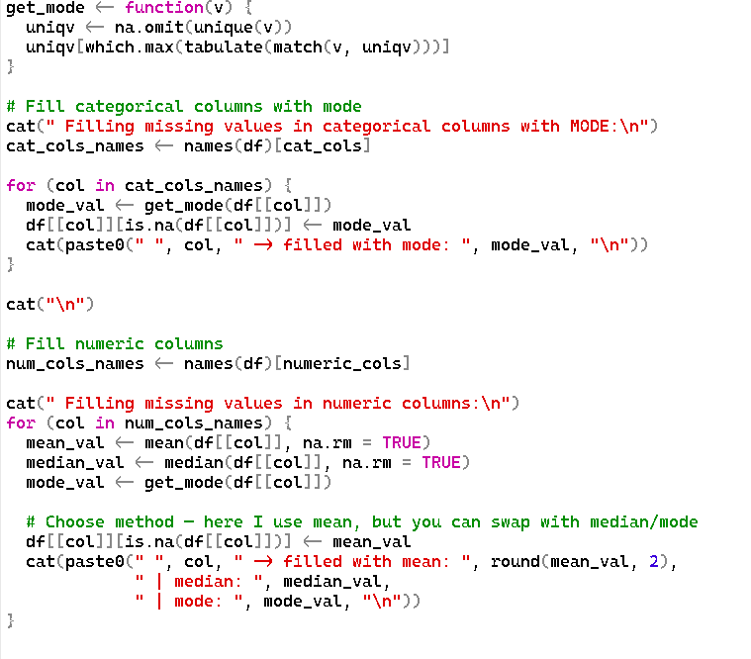

**Output**

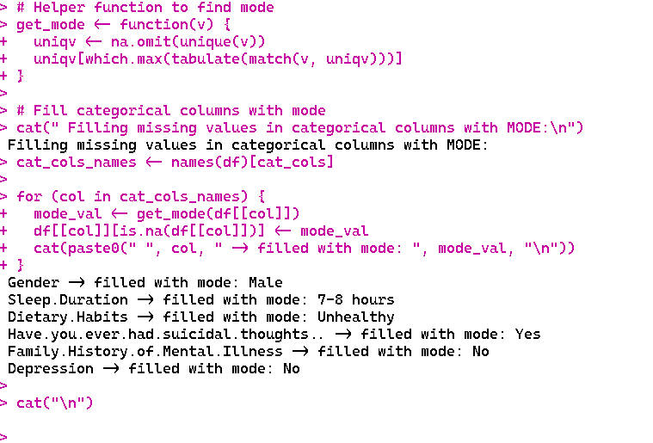

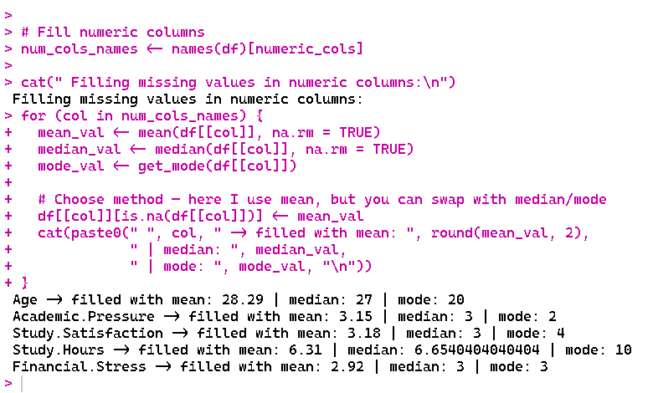

**Check Missing Value**

**Code**

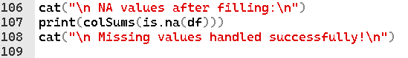

**Output**

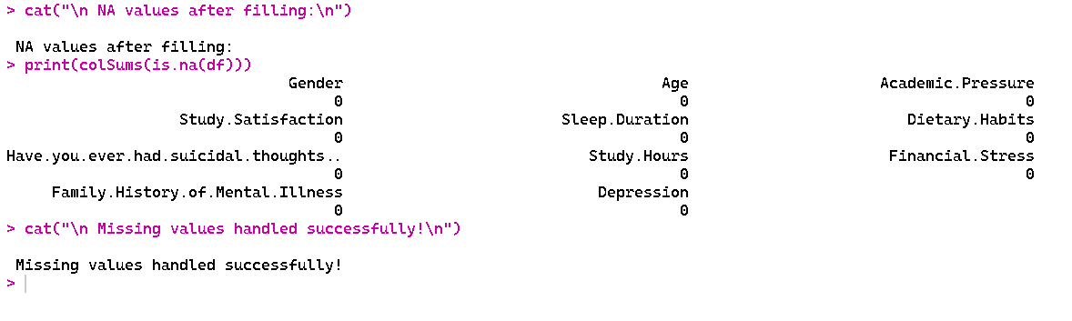

**Invalid Value**

**Code**

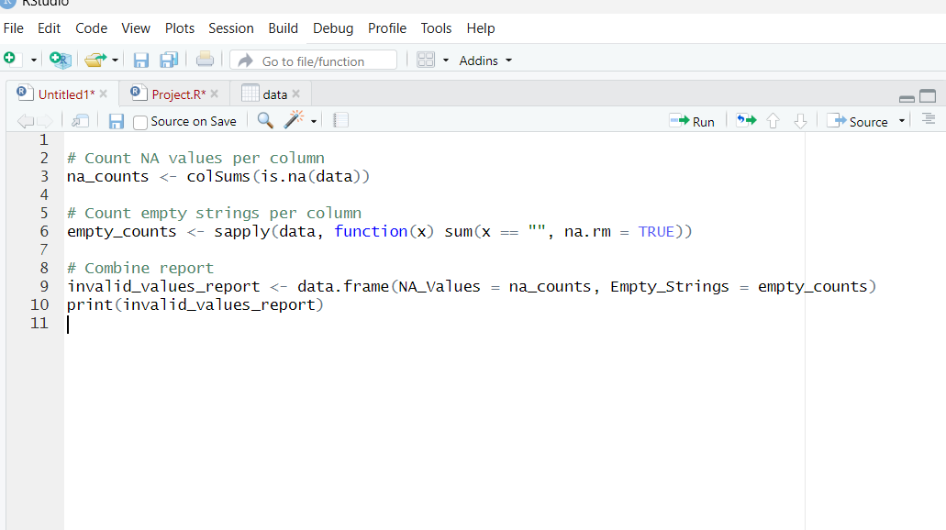

**Output**

**Noisy Value**

**Code**

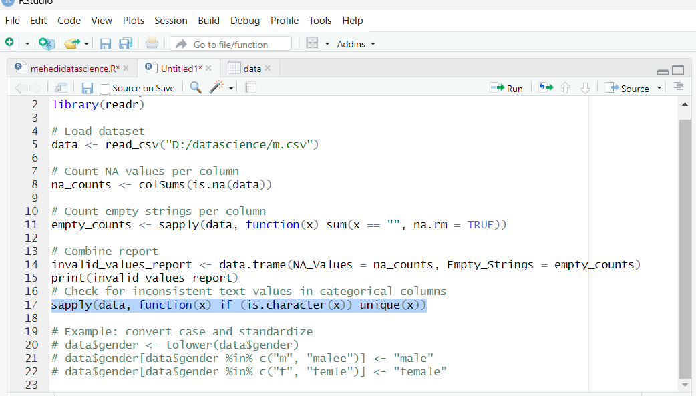

**Output**

**Measure of central tendency**

**Code:**

**Output**

**Measure of spread**

**Code**

**Output**

**Normallization**

**Code**

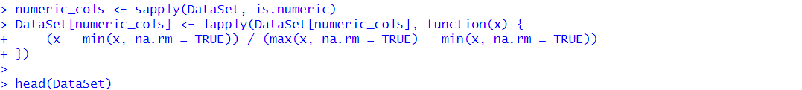

**Output**

**Outliers**

**Code**

**Output**

**Train Test Split**.

**Code**

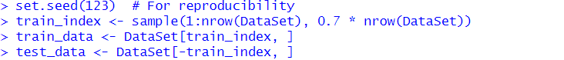

**Output**

**Sampling**

**Description**

**sampling** refers to randomly selecting a portion of the dataset’s rows to create subsets for model training and testing. It ensures that each row has an equal chance of being chosen, helping maintain the dataset’s overall distribution while preventing bias.

**Code**



**Output**

